**QUIZ 8º ANO – LÍNGUA INGLESA 4º BIMESTRE**

1. Qual a forma correta do comparativo para completar a frase abaixo?

Mato Grosso do Sul is ___ Ceará.

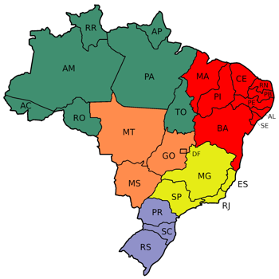

a) more big

b) biger

c) bigger

d) more biger

2. Sergipe is ___________ state in Brazil.



a) smaller

b) more small

c) the more small

d) the smallest

3. Qual a forma correta do comparativo para completar a frase “ Soccer is ____ baseball”.

a) gooder than

b) the better

c) more interesting than

d) interestinger than

4. Qual a forma correta para completar a frase “Canada is _______________ Brazil”.

a) the bigger

b) bigger than

c) warmer than

d) hotter than

5. Assinale a alternativa que completa corretamente a frase “This car is certainly ***_______***but it's much ***_______”***.

a) better - more expensive

b) good - expensiver

c) gooder - expensiver

c) more good - more expensive

**RESPOSTAS:** 1.c; 2.d; 3.c; 4.b; 5.a