**QUIZ 5º ANO - INGLÊS 4º BIMESTRE**

1. What are these?



1. Plastic bottles
2. Glasses
3. Reusable bags
4. Cans

2. O que este símbolo significa?



1. Eat organics.
2. Save water.
3. recycle
4. Save energy

3. What’s this?

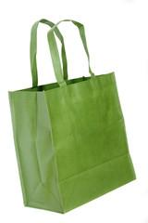

1. It’s a plastic bottle.
2. It’s a glass.
3. It’s a paper.
4. It’s a reusable bag.

4.Que atitude esta imagem sugere?



1. Save energy.
2. Eat organics.
3. Don’t waste water.
4. Recycle.

5. Que atitude esta imagem sugere?



1. Eat organics.
2. Protect the planet.
3. Reuse bags.
4. Save energy

**RESPOSTAS:** 1.a; 2. c; 3.d; 4.b; 5.B