**QUIZ 4º ANO - INGLÊS 4º BIMESTRE**

1. She’s from the United States. She is ___________.



1. English
2. American
3. Mexican
4. Russian

2.What’s her nationality?

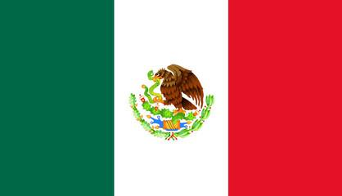



1. She’s Chinese.
2. She’s Japanese.
3. She’s Brazilian.
4. She’s Mexican.

3. Is he English?



1. Yes, he is.
2. Yes,she is.
3. No, he isn’t.
4. No, she isn’t.

4. He is from Australia.He is __________.



1. American.
2. Italian.
3. Australian.
4. Russian.

5. Is she Russian?



1. No, she isn’t.
2. No, he isn’t.
3. Yes,she is
4. Yes,he is.

**RESPOSTAS:** 1. b; 2.d; 3. a; 4. c; 5. A