**QUIZ 3º ANO - INGLÊS 4º BIMESTRE**

1.What place is this?



1. a bank.
2. a park.
3. a library.
4. a supermarket.

2. What place is this?



1. It’s a supermarket.
2. It’s a church.
3. It’s a museum.
4. It’s a park.

3.What place is this?

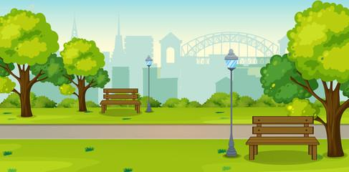

1. This is a supermarket.
2. This is a museum.
3. This is school.
4. This is a park.

4. What place is this?



1. a park.
2. a school.
3. a library.
4. A bank.

5. What place is this?

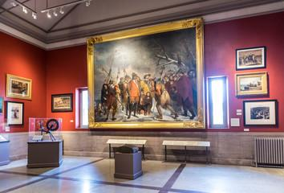

1. It’s a school.
2. It’s a park.
3. It’s a museum.
4. It’s a supermarket.

**RESPOSTAS:** 1. c; 2. a; 3.d; 4. b; 5.c