**QUIZ 4º ANO – LÍNGUA INGLESA 3º BIMESTRE**

1. Who is she?



1. She’s a painter.
2. She’s a photographer.
3. She’s a gardener.
4. She’s a veterinarian.

2. What’s his occupation?



1. A dentist.
2. A nurse.
3. A doctor.
4. A teacher.

3. Who is he?



1. He’s an engineer.
2. He’s a dentist.
3. He’s a doctor.
4. He’s a policeman.

4. What’s her occupation?



1. A police.
2. A firefighter.
3. A mechanic.
4. A nurse.

5. Who is he?

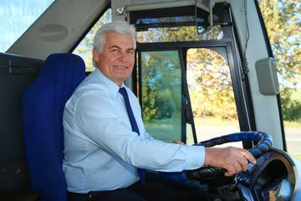

1. He is an engineer.
2. He is a pilot.
3. He is a mechanic.
4. He is a bus driver.

**RESPOSTAS:** 1.c; 2.c; 3.a; 4. b; 5. d