**QUIZ 3º ANO – LÍNGUA INGLESA 3º BIMESTRE**

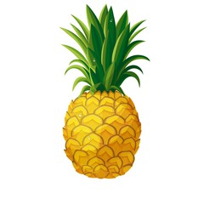

1. What fruit is this?
2. It’s an apple.
3. It’s a papaya.
4. It’s a pineapple.
5. It’s a banana.

2. What vegetable is this? 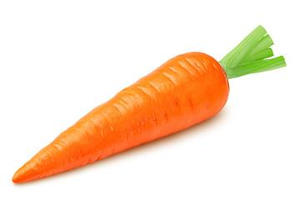

1. This is a broccoli.
2. This is a carrot.
3. This is a pumpkin.
4. This is a tomato.

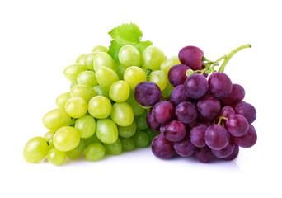

3. What are these?

1. These are grapes.
2. These are strawberries.
3. These are lemons.
4. These are papayas.

4. What’s this? 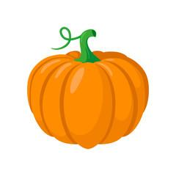

1. A carrot.
2. A tomato.
3. A potato.
4. A pumpkin.

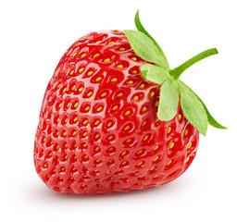

5. What’s this?

1. It’s an apple.
2. It’s na orange.
3. It’s a potato.
4. It’s a strawberry.

**RESPOSTAS:** 1. c; 2.b; 3.a; 4. d; 5. d