QUIZ 4º ANO – INGLÊS 2º BIMESTRE
Na nossa aula aprendemos sobre o uso das palavras: IN, ON, UNDER, BEHIND, NEXT TO, IN FRONT OF. Observe as figuras, depois leia com atenção cada uma das perguntas e marque a alternativa que tem a resposta correta. Vamos ver o quanto você aprendeu?

1.Where is the dog?

a) It’s under the car.
b) It’s in the car.
c) It’s behind the car.
d) It’s next to the car.

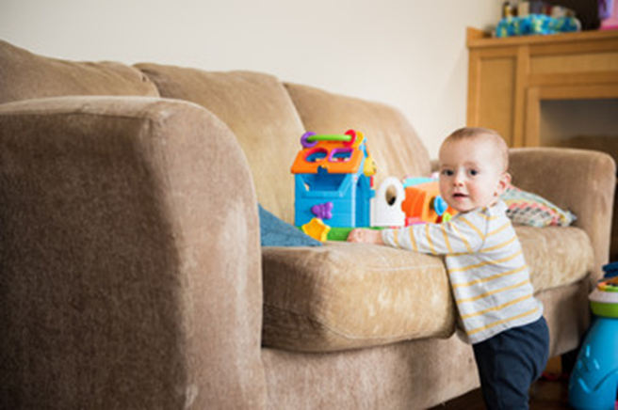
2.Where are the toys?

a) The toys are on the sofa.
b) The toys are behind the sofa.
c) The toys are next to the sofa.
d) The toys are in the sofa.

3.Where is the girl?

a) The girl is next to the door.
b) The girl is under the door.
c) The girl is in front of the door
d) The girl is behind the door.

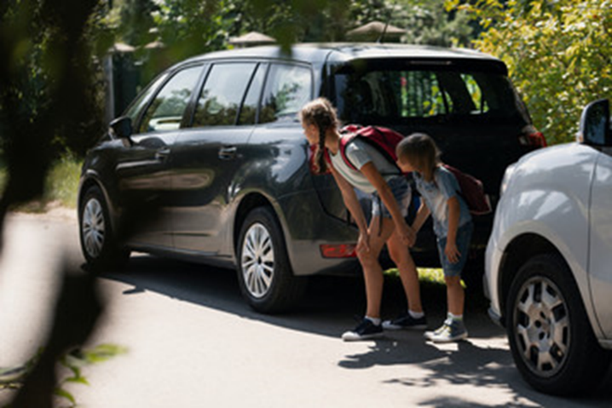
4.Where are the kids?

a) The kids are in front of the two cars.
b) The kids are behind the two cars.
c) The kids are between the two cars.
d) The kids are next to the two cars.

5.Where is the boy?

a) The boy is next to the christmas tree.
b) The boy is behind the christmas tree.
c) The boy is in front of the christmas tree.
d) The boy is on the christmas tree.

RESPOSTAS: 1.b; 2.a; 3.d; 4.c; 5.a

