QUIZ 3º ANO – INGLÊS 2º BIMESTRE
Na nossa aula aprendemos sobre o uso do THIS / THAT / THESE / THOSE.
Observe as figuras, depois leia com atenção cada uma das perguntas e marque a alternativa que tem a resposta correta. Vamos ver o quanto você aprendeu?

1.What’s this?
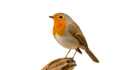
- This is a lion.
- This is a bird.
- This is a snake.
- This is a monkey.

2.What’s that?

- That is a panda.
- That is an elephant.
- That is a tiger
- That is a lion.

3.What are those?

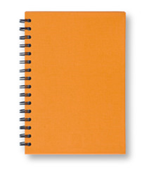
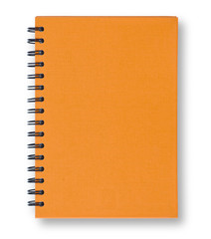

- Those are notebooks.
- Those are books.
- Those are pencils.
- Those are erasers.

4.What are these ?

a)These are erasers.
b)These are books.
c)These are notebooks.
d)These are pencils.

5.What’s that?

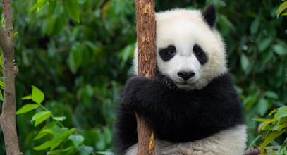

- That is a lion.
- That is a tiger.
- That is an alligator.
- That is a panda.

RESPOSTAS: 1.b; 2.C; 3.a; 4.d; 5.d

